|  |  |
| --- | --- |
| Actions performed by Actors | System Response |
| 1. User enters their name, address and phone number |  |
|  | 1. Creates a new unique ID for the client, sets the balance to 0, and stores them in a list |

Add client

Use-Case Chart

Remove Client

Use-Case Chart

|  |  |
| --- | --- |
| Actions performed by Actors | System Response |
| 1. User enters client ID to be removed. |  |
|  | 1. Verify that the ID exists. If not, exit to the command prompt   Check to make sure the client in question does not have a current or future show scheduled. If so, alert the user that the client can not be removed for this reason.  If no complications, remove the client from the list. |

List all Clients

Use-Case Chart

|  |  |
| --- | --- |
| Actions performed by Actors | System Response |
| 1. Users selects option to list every client |  |
|  | 1. System loops through and prints all clients in the list |

Add customer

Use-Case Chart

|  |  |
| --- | --- |
| Actions performed by Actors | System Response |
| 1. User enters the name, address, phone number, and the number and expiration date of exactly one credit card |  |
|  | 1. Saves the customer details and continues to verify that the credit card is not already on file with another customer.   If it already exists on file, alert the user and return to the command prompt  If the information is valid, create a unique customer ID and store the new customer in the customer list |

Remove customer

Use-Case Chart

|  |  |
| --- | --- |
| Actions performed by Actors | System Response |
| 1. Customer requests account deletion |  |
| 1. Clerk issues request to remove customer by pressing “5” in the command GUI |  |
|  | 1. System asks for Customer ID |
| 1. Clerk asks Customer for ID |  |
| 1. Customer gives Clerk ID |  |
| 1. Clerk inputs Customer ID |  |
|  | 1. System verifies Customer ID. Displays customer was found. Otherwise, displays customer was not found and exits. |
|  | 1. System proceeds to delete all information related to Customer ID (name, address, phone number, number and expiry date of all credit cards). It displays that the customer was successfully deleted. |

Add Credit Card

Use-Case Chart

|  |  |
| --- | --- |
| Actions Performed by Actor | System Response |
| 1. Customer requests to add a credit card to account |  |
| 1. Clerk issues request to add a credit card by pressing “6” into the command GUI |  |
|  | 1. System requests for Customer ID |
| 1. Clerk inputs Customer ID |  |
|  | 1. System verifies Customer ID. Displays customer was found. Otherwise, displays customer was not found and exits. |
|  | 1. System requests for credit card number and expiry date. |
| 1. Clerk inputs credit card number and expiry date. |  |
|  | 1. System attaches credit card information to the customer ID. It displays that the card was successfully added. |

Remove Credit Card

Use-Case Chart

|  |  |
| --- | --- |
| Actions performed by Actors | System Response |
| 1. Customer requests credit card deletion |  |
| 1. Clerk issues request to remove credit card by pressing “7” in the command GUI |  |
|  | 1. System asks for credit card number |
| 1. Clerk inputs credit card number |  |
|  | 1. System verifies if it has the credit card. It displays credit card found. Otherwise, displays credit card not found and exits. |
|  | 1. System verifies if the credit card attached to the Customer ID is the only one or one of many credit cards. All information related about the credit card is deleted, and displays credit card was removed if there are more than one credit card associated with the Customer ID. Otherwise, it displays failed to delete credit card due to it being the only credit card associated with the Customer ID. |

List Customers

Use-Case Chart

|  |  |
| --- | --- |
| Actions performed by Actors | System Response |
| 1. Customer asks if they have an account in the system |  |
| 1. Clerk issues request to list all customers by pressing “8” in the command GUI |  |
|  | 1. System finds all customer ID’s, and print every information associated to the ID |
| 1. Clerk finds if the customer exists in the list |  |

Add a Show

Use-Case Chart

|  |  |
| --- | --- |
| Actions performed by Actor | System Response |
| 1. User requests to add a new show |  |
|  | 1. System asks for ClientID, name of show, and date range |
| 1. User provides ClientID, name of show, and date range |  |
|  | 1. System checks if date range has overlap with any other shows |
|  | 1. If no overlap, use input data to create a new show listing |
|  | 1. Inform the user that the show was added |
|  | 1. Output the new show information to the user |

List All Shows

Use-Case Chart

|  |  |
| --- | --- |
| Actions performed by Actor | System Response |
| 1. User requests to see all available shows |  |
|  | 1. System retrieves the listing of shows |
|  | 1. System iterates through the list of shows displaying them to the user |

Store Data

Use-Case Chart

|  |  |
| --- | --- |
| Actions performed by Actor | System Response |
| 1. User requests to store all theater related data |  |
|  | 1. Stores an array of Clients onto the disk in an .ser file. |
|  | 1. Stores an array of Customers onto the disk in an .ser file |
|  | 1. Stores an array of Credit Cards onto the disk in an .ser file |
|  | 1. Stores an array of all shows onto the disk in an .ser file |
|  | 1. Informs the user that storage was successful in an .ser file |

Retrieve Data

Use-Case Chart

|  |  |
| --- | --- |
| Actions performed by Actor | System Response |
| 1. User requests to retrieve all theater related data |  |
|  | 1. Retrieves an array of Clients from the disk .ser file |
|  | 1. Retrieves an array of Customers from the disk .ser file |
|  | 1. Retrieves an array of Credit Cards from the |
|  | 1. Retrieves an array of all Shows from the disk .ser file |
|  | 1. Inform user that retrieval was successful |

Sell Regular Tickets

|  |  |
| --- | --- |
| Actions performed by Actor | System Response |
| 1. Customer asks for tickets on day of showing |  |
| 1. Clerk selects ‘sell regular tickets’ |  |
|  | 1. Systems asks for quantity, customer ID, credit card number, and date of show |
| 1. Clerk inputs quantity, customer ID, credit card number, and date of show |  |
|  | 1. System verifies that the date entered matches that of the current date and that the show is currently showing on this date |
|  | 1. System process regular tickets to customer. Customer is charged the regular, full ticket price |
|  | 1. Balance updates in revenue for theater and client. |
| 1. Clerk hands customer tickets after purchase |  |

Use-Case Chart

Sell Advanced Tickets

|  |  |
| --- | --- |
| Actions performed by Actor | System Response |
| 1. Customer purchase tickets at least one day before showing |  |
| 1. Clerk chooses advance tickets selection |  |
|  | 1. Systems asks for quantity, customer ID, credit card number, and date of show |
| 1. Clerk inputs quantity, customer ID, credit card number, and date of show |  |
|  | 1. System process advance tickets to customer. Customer is charged 70% of regular show tickets. |
|  | 1. Balance updates in revenue for theater and client. |
| 1. Clerk hands customer amount of tickets purchased |  |

Use-Case Chart

Sell Student Advance Tickets

|  |  |
| --- | --- |
| Actions performed by Actor | System Response |
| 1. Customer asks for student advance tickets at least one day before showing |  |
| 1. Clerk selects ‘student advance tickets’ |  |
|  | 1. Systems asks for quantity, customer ID, credit card number, and date of show |
| 1. Clerk inputs quantity, customer ID, credit card number, and date of show |  |
|  | 1. System process advance tickets to customer. Customer is charged 50% of regular show tickets. |
|  | 1. Balance updates in revenue for theater and client. |
|  | 1. System reminds clerk that a unique individual will need to show a student ID for each student advance ticket redeemed on the date of the show |
| 1. Clerk hands the customer the correct number of student advance tickets sold |  |
| 1. Each student presents ID with ticket purchased when they go to see the show |  |

Use-Case Chart

Pay Client

Use-Case Chart

|  |  |
| --- | --- |
| Actions performed by Actors | Actions by System |
| 1. Clerk selects ‘pay client’ option |  |
|  | 1. System asks for client ID |
| 1. Clerk enters client ID |  |
|  | 1. System verifies that the ID is correct a |
|  | 1. System displays the clients balance and asks the clerk to enter the amount to be paid to the client |
| 1. Clerk enters amount to be paid |  |
|  | 1. System verifies the amount does not exceed the clients balance |
|  | 1. System subtracts the amount entered from the clients balance and updates the clients balance |

List all tickets for a certain day

Use-Case Chart

|  |  |
| --- | --- |
| Actions performed by Actors | Actions by System |
| 1. Clerk selects ‘List all tickets on certain day’ option |  |
|  | 1. System asks for the date in question |
| 1. Clerk enters date |  |
|  | 1. System verifies that the date was entered correctly |
|  | 1. System displays all tickets, with all their details, sold for show/s on this date |

Help

Use-Case Chart

|  |  |
| --- | --- |
| Actions performed by Actor | System Response |
| 1. Clerk unsure of usage on each command and requests help |  |
|  | 1. System displays in detail what each command does |

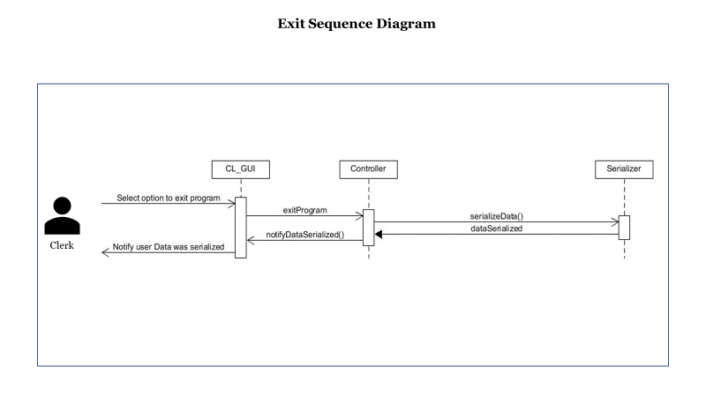

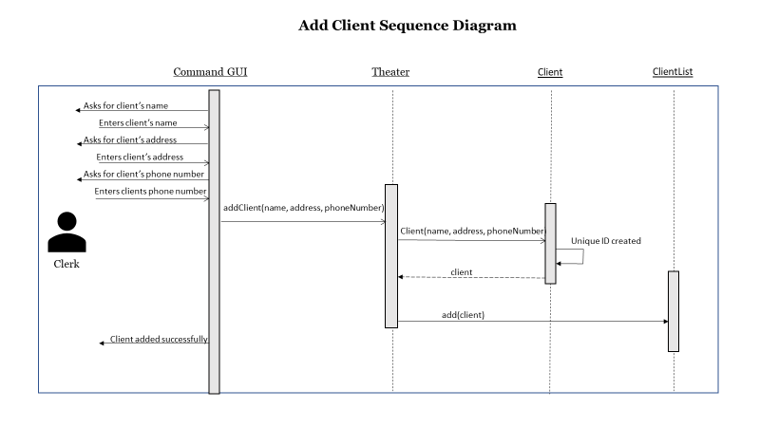

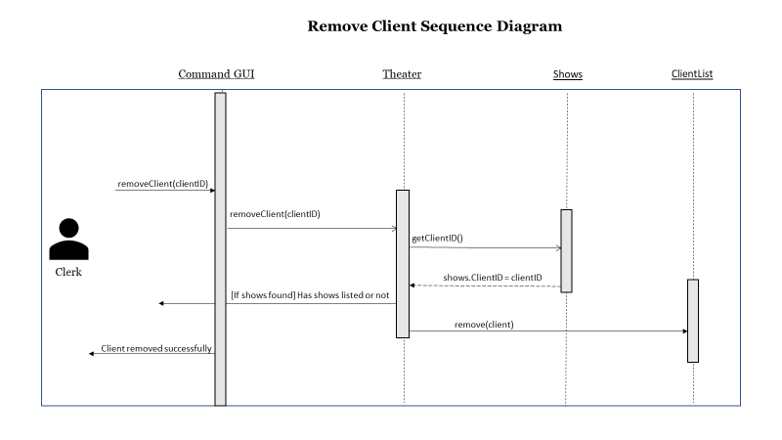

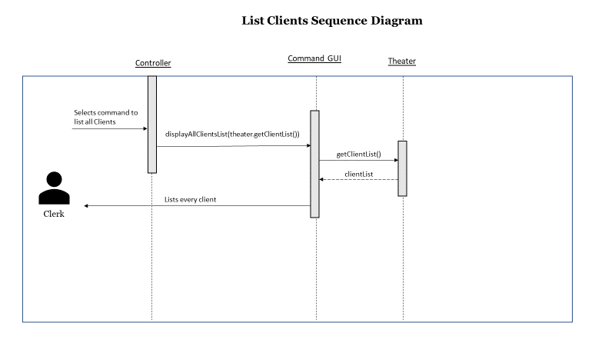

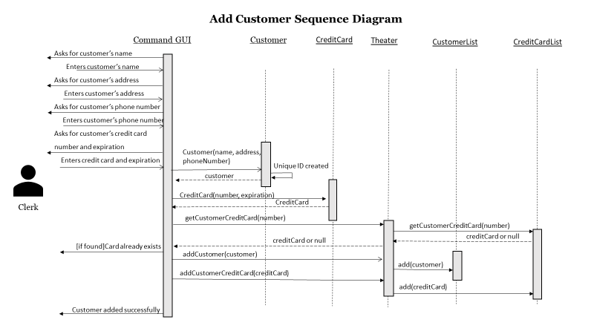

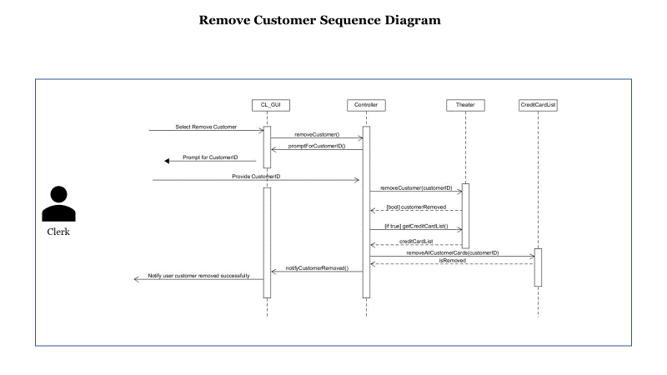

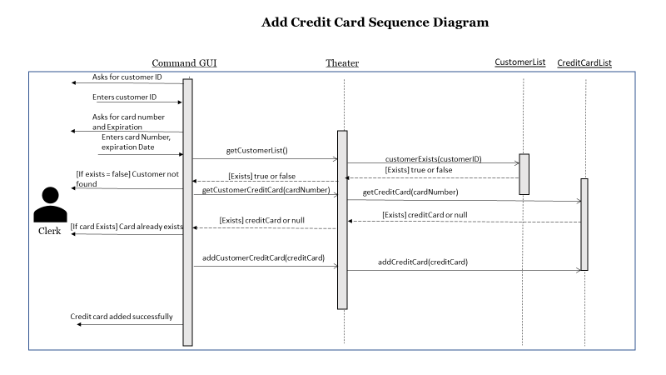

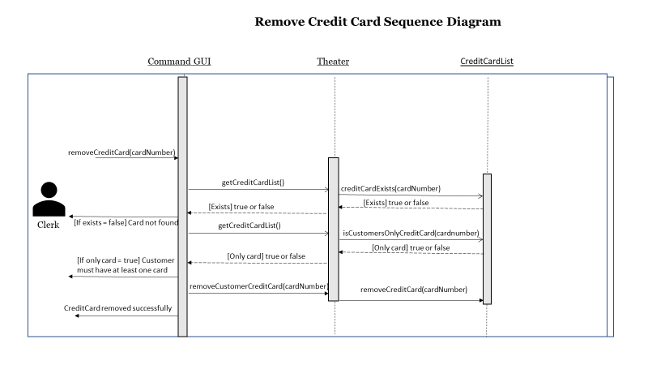

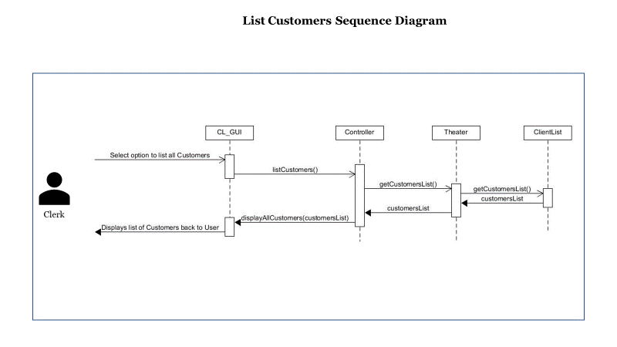

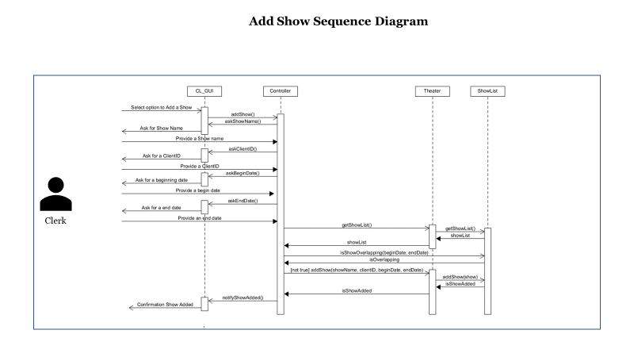

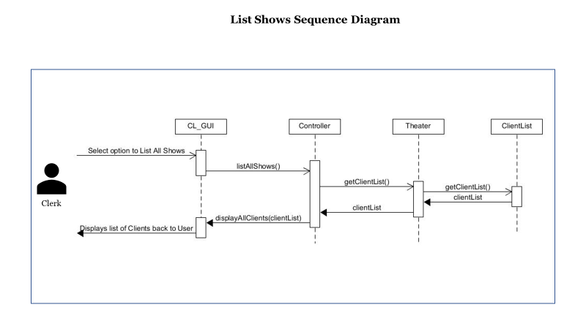

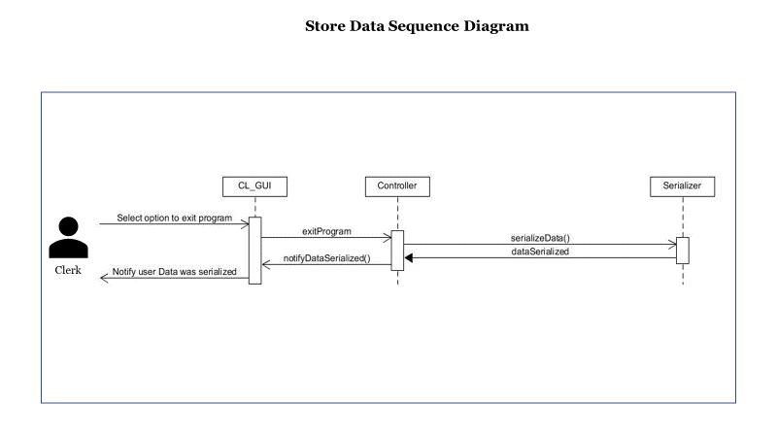

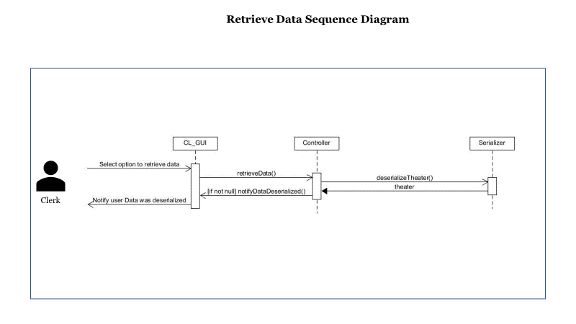

Sell Regular Ticket

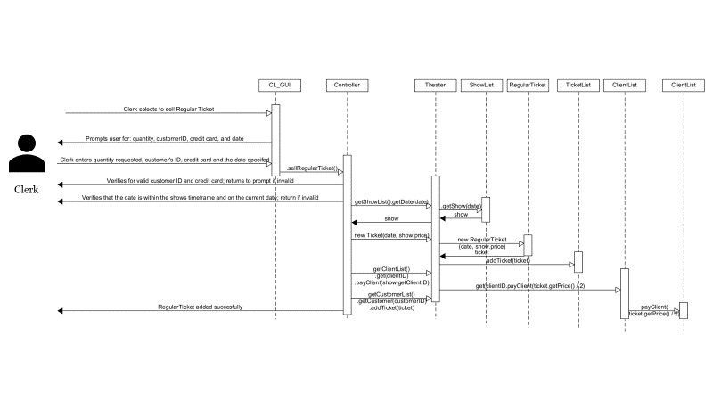

Sell Advance Ticket

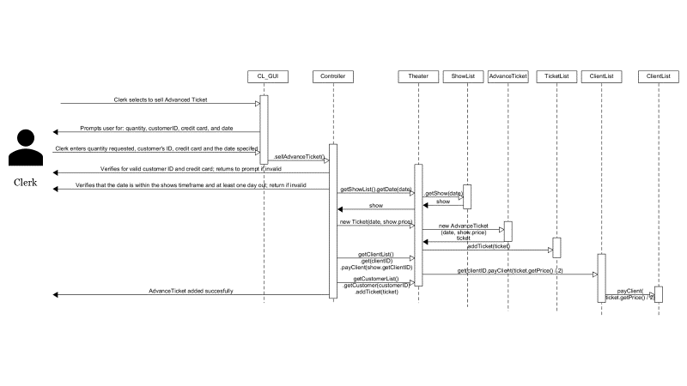

Sell Student Advance Ticket

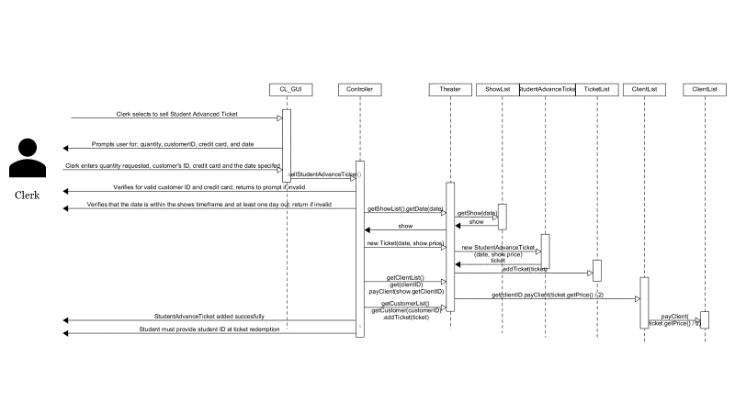

Pay Client

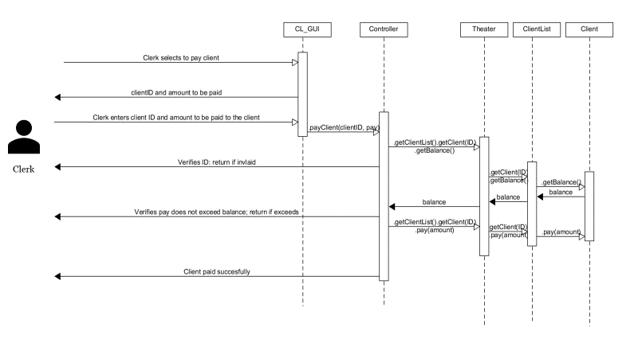

Display all Tickets on certain Day

